Name: Class:
Introduction
The corrosion of iron, and subsequent rust formation, is an example of a redox reaction. This particular redox reaction is one that costs the Australian economy millions of dollars per year. In this worksheet we will consider factors that affect the rate of corrosion of iron, and some methods to prevent or slow corrosion.
The diagram below shows four tubes, each containing iron nails. Tubes were set up and left for several days. The results obtained for the experiment are given below the test tubes. Consider these results when answering the following questions.
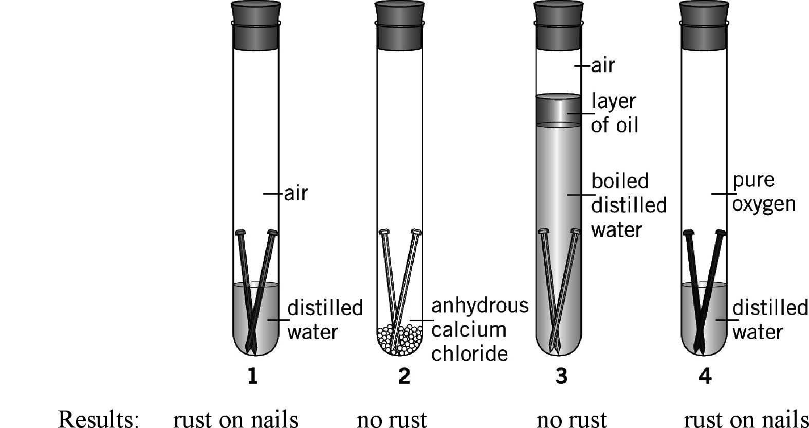

No | Question | Answer
Write balanced half-equations for:
a the oxidation of iron atoms to iron(II) ions
b the reduction of oxygen in the presence of water to form hydroxide ions.
 | Suggest why no corrosion has occurred in tube 2.
 | Suggest why no corrosion has occurred in tube 3.
 | More rust formed in tube 4 than in tube 1. Suggest a reason for this.
Suggest why corrosion of an iron object is reduced (or stopped) in each of the following situations:
a Outer space
b At the bottom of the ocean
c When the object is coated with oil
d When connected with a wire to a piece of magnesium
e When the object is connected to the negative terminal of a DC power supply (called cathodic protection).
Metal rubbish bins are often coated with zinc. Metal food containers are coated with tin.
a State two ways in which the zinc coating on rubbish bins protects the iron from corrosion.
b State one way in which the tin coating on containers protects the iron from corroding.
c Why is a zinc coating not suitable for use on food containers?
Match each iron object to an appropriate corrosion prevention method.

Gardening secateurs | Galvanising (coating with Zn)
Natural gas pipeline | Cathodic protection with a DC power supply
Wharf | Coating with oil
Patio furniture | Attachment to sacrificial anodic magnesium blocks
A shed roof | Painting

